1255 Field Parkway  Marietta, GA 30066  (770) 528-0881  www.georgiaballet.org
Cinderella

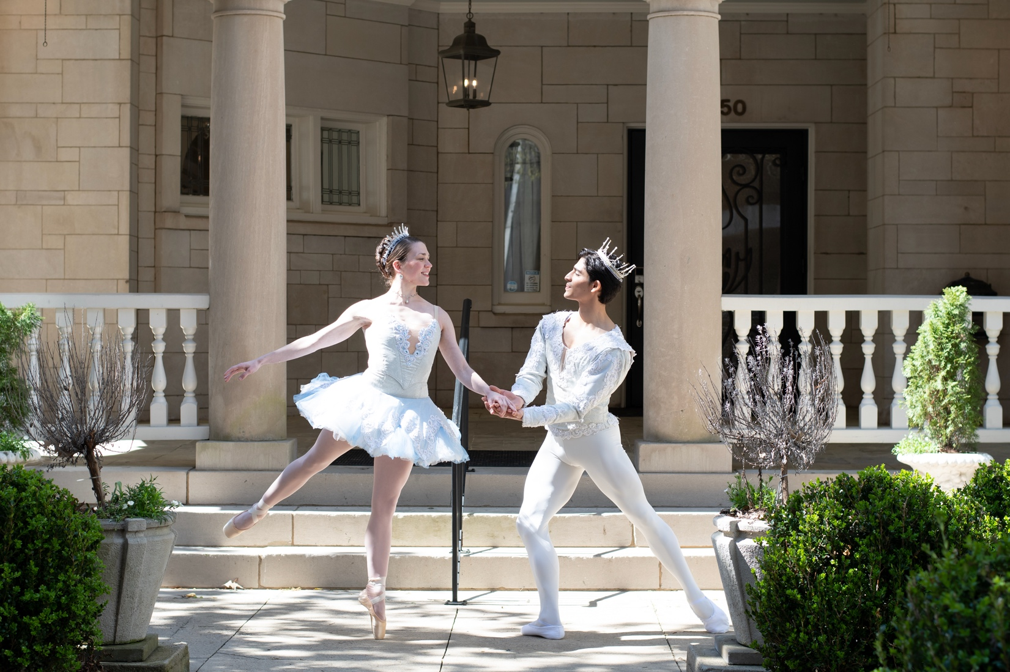

An Enrichment Guide
For Elementary Grades
Presented by The Georgia Ballet
A NOTE TO EDUCATORS

The following enrichment guide is meant as a resource for educators to use in an educational setting in conjunction with The Georgia Ballet’s production of Cinderella. The guide includes a synopsis of the ballet as well as content activities that can be incorporated into a larger unit of study. These content activities are merely suggestions, and educators should feel free to adapt the activities to suit the needs of their curriculum and level of study.

We here at The Georgia Ballet are so pleased to be able to present this production for study. We hope that it inspires an appreciation for dance and music in those it reaches.

The Georgia Ballet

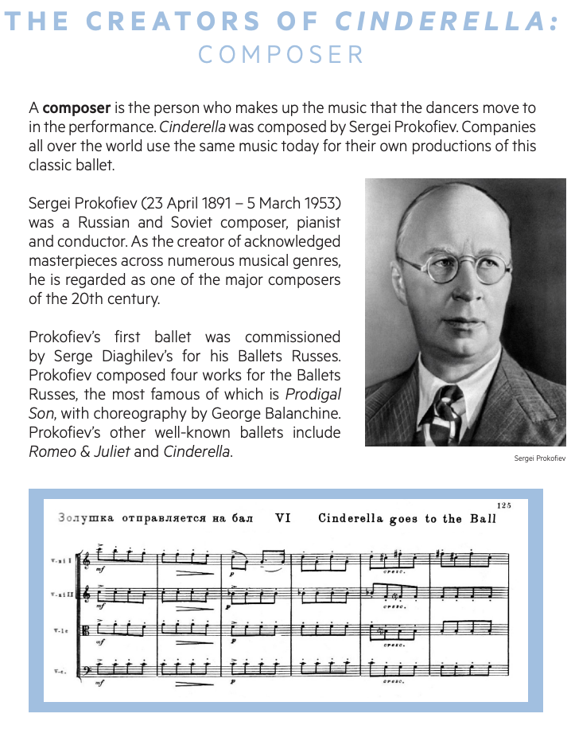

C H O R E O G R A P H E R

A choreographer is the person who makes up the steps that the dancers do in the performance. Cinderella was first choreographed by Rostislav Zakharov in 1945 for the Bolshoi Ballet in Moscow, Russia.

Daet Rodriguez and Margit Peguero choreographed their version of Cinderella for this Georgia Ballet premier of the production in 2023!
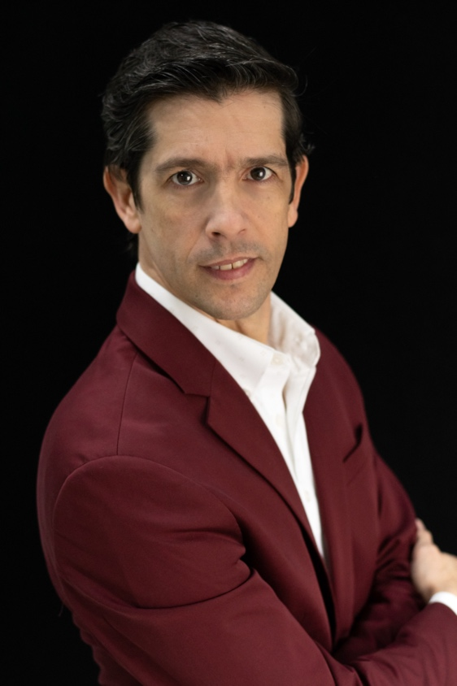
Daet Rodriguez was born and raised in Cuba and graduated from the National School of Ballet in Havana in 1990. His training consisted of his parents Jorge Rodriguez Vede and Clara Diaz along with Fernando Alonso, Alberto Alonso, Laura Alonso, Pablo More and Lazaro Carreno. Daet’s professional career began with Ballet de Camguey where he has performed many classical and contemporary principal roles. In 1995, Daet joined Teatro Centro de Art-Leon Febres Cordero in Ecuador where he added Balanchine performance experience to his repertoire. His career extended to many other countries including: Cuba, Jamaica, Argentina, Chile, Mexico, Canada, Martinique, Guadalupe and the United States, In 2001, Daet and his wife, Margit, opened their own ballet school, Cuballet-Ecuador. Here they served over 200 students in a classical and contemporary training program. In February of 2015, Daet, Margit and their two children moved to the United States and set ballets and choreography on schools around the region before joining us here at The Georgia Ballet. Since then, they have premiered several full length ballets and look forward to presenting even more.

